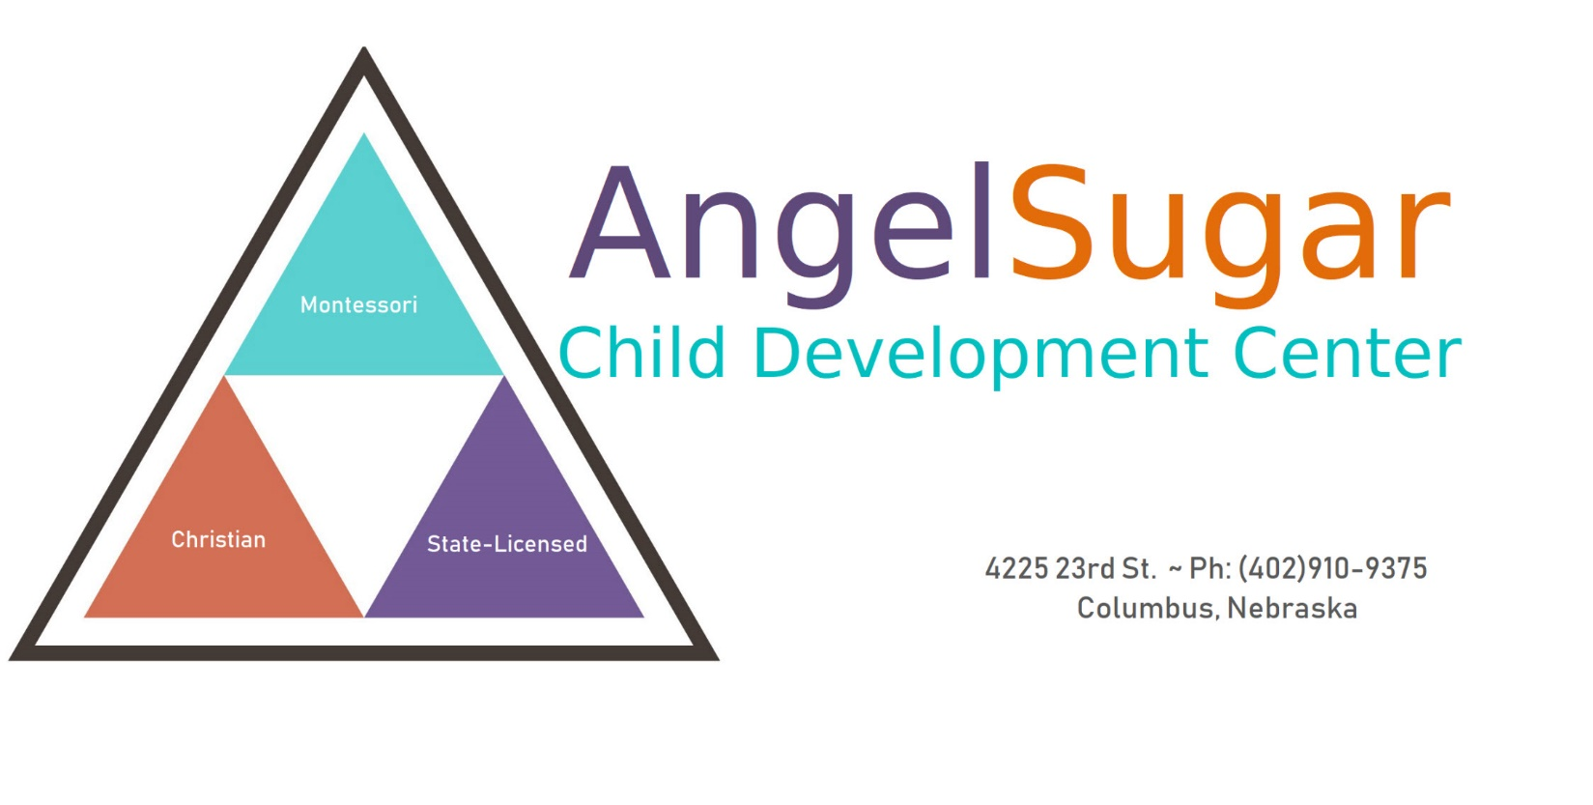

  - PARENT HANDBOOK

Procedures & Policies

(2022 – 2023)

Center Information

Center Phone # : (402) 910-9375
Director’s Email: Stacy@AngelSugarPreschool.com
School Website: www.AngelSugarPreschool.com
Center Hours: 7:00am – 6:00pm, Monday-Friday
Center Capacity: 28 children (ages 2–5 years)

Stacy Soward, Owner & Director – Experience & Education

As the owner & director of AngelSugar Child Development Center, I have the following experience with working with children:
- (1999) Graduated with Bachelor’s Degree in Child Development & Family Studies, University of North Texas (Dean’s List & A/B Honor Roll)
- (1994-1996) Attended the University of Nebraska-Lincoln, Business Management
- (3 years) Preschool Teacher, BrightStart Montessori Preschool (Louisiana)
- (3 years) Director, Tender Care Academy (Louisiana), 200+ capacity childcare center, served ages 6 weeks – 5 years
- (4 years) Private, in-home daycare provider (Louisiana)
- (2 years) Education Counselor for Girls, Inc. youth organization (Dallas, TX)
- Published Author of youth skills handbook, curriculum used for youth services group in Dallas, Texas (Challenges & Choices, 1999)
- (2 years) State of Nebraska Child Protective Services, visitation supervisor of court-ordered, controlled visits between parent/kids
- 1993 Graduate of Scotus Central Catholic
- In addition, I grew up around kids my whole life. My mother ran an in-home daycare center for 36 years. I’m also a mother of 2 daughters & 2 sons.

Staff Qualifications
We are all professionals in the childcare field, with lots of experience and training in working with and caring for young children. All staff must pass a criminal background check, a sex-offender registry check, and a child/adult abuse background check through the state. All staff must be CPR and First Aid Certified. Most of our team has either a 2-year or 4-year degree in early childhood education, or related field. In addition, all staff must complete 12 hours of continued education per year. And all staff must maintain a clean police record and pass a physical health check yearly. Our team upholds the highest of standards!

General Policy
The biggest center policy we have is RESPECT, and treat others as you’d like to be treated. We will show both you and your child respect at all times, and we ask that you do the same with us. When you are at our center, we expect the parents to act and speak in an appropriate manner. Inappropriate language & behavior will not be tolerated. Please remember that our young children see and hear everything! As a “Child Development Center”, we aim to teach, develop, and nurture the “whole” child – the basic fundamentals of education (reading & writing), number & math concepts, interpersonal skills, boundaries, social development with friends, personal emotions & reactions, manners, respect for authority, consequences of actions, and healthy habits. Side note: When entering and leaving the center, do not allow your kids to run around the parking lot, they must stay within arm’s reach of you. Our center traffic is increasing all the time, and cars drive in quickly and aren’t looking for loose kids in the lot. Let’s avoid accidents!

Your Student File
When you enroll, you are given the forms that must be signed and in your child’s file. Your child’s shot (immunization) records must be current and correct. When you take your child in for new immunizations, please request an updated copy for the center. If you move, change your phone number, change jobs, or change the people who are allowed to pick your child up, we will need the information updated in your file as well.

Student Supplies
The following supplies need to be in your child’s cubby at all times: light jacket, & change of clothes (bottoms, undies/panties, socks, shirt). We need 2 sets of clothes if your child is in diapers or potty training. When one set goes home, we still have the 2nd set until you bring the clothes back. If your child does not have extra clothes available, we will use our back-up supplies, and you will need to wash them and return the items as soon as possible. For children in diapers, we need these items for their drawer: diapers/pull-ups, wet wipes, & butt cream. When supplies run low, our staff will make that note on your child’s Daily Report. Please bring more within 1-2 days. We also need: 1 water bottle (small), one nap blanket (toddler size), one stuffed animal for nap time if desired, and a toddler-size pillow. All nap bedding will go home on the last Friday of every month to be laundered and brought back on Monday. All water bottles will go home at the end of the week to be washed and brought back Monday. Please do not allow your child to bring toys, trinkets, and other items from home. They could be a choking hazard to our toddlers, and we do not want the responsibility of the safety of these items from your home. SHOES: Because we have mulch on our playground, all kids are required to wear closed-toe shoes (sneakers) at all times. No sandals, flip flops, or crocs please – the mulch gets in their shoes, and they spend the entire recess trying to get mulch out.

Breakfast ( 7:00 – 8:00 )
Breakfast is provided for your child if they are dropped off between 7:00-8:00 am. We provide fruit breakfast bars and milk. Do not bring any other breakfast with your child, including special drinks, as it’s not fair to all the other children that they have something different. Please feed your child breakfast at home if you don’t want them to have our fruit bar, or if you will be arriving after 8:00am. Also, as a state regulation, when you drop off and pick up your child, they MUST be correctly buckled in a secure car seat.

Lunch ( 11:00 ) and Lunch Boxes
At enrollment, you will be given 2 lunch boxes. You’ll be required to provide your own child’s lunch in our provided lunch box daily. It is mandatory that the children’s lunches be healthy and wholesome. Typical lunches include a sandwich or main entrée item, side of fruit/veggie, yogurt, etc. Do not include chocolate items, fruit gummies, desserts, or high sugar/fat items. We will send these items back home. The children have a real hard time at nap if they’re loaded up on sugar and/or high fat foods. It gives them tummy aches and makes them restless at nap. Lunches are cold, and stored in the frig. We cannot warm lunches in the microwave, per state food regulations. You are welcome to bring warm items in your own thermos if you choose. Uneaten food will be returned home, so you can see how much was ate that day. We provide vitamin D milk for all the children for lunch, so no drink is needed. If your child has a lactose intolerance, you will need to provide a carton of milk for them that they can have with their lunch. We will let you know when it’s getting low. The children are given approximately 30-40 minutes to eat lunch, and are always encouraged to eat as much as they can. If they eat everything, we cheer for them and call it a “Happy Box!” So please provide amounts they are capable of finishing in one meal.

Nap Time ( 12:00 – 2:00 )
Immediately following lunch, is nap time. A children’s show is put on to relax them and get them all settled. The toddlers receive 15-30 minutes of TV time, and the older kids receive 30-60 minutes. After that, a lullaby goes on. Children don’t have to sleep, obviously, but they do need to lay still and be quiet so others can sleep. Quiet time is very important for young children, as their busy little bodies need a rest. If the majority of kids do not fall asleep within the first hour, nap will occasionally be extended until 2:20 at the latest.

Snack ( 2:45 )
We provide a snack for the children every day, along with filtered water in your child’s water bottle. Typical snack items include: graham crackers, animal crackers, pretzels, low-sugar cookies, goldfish, etc. Do not send items for your own child’s snack, as it causes problems with the rest of the group who aren’t offered it. If your child has allergies to any of these foods, you will need to note that on the enrollment form.

Birthdays & Pizza Parties
On your child’s birthday, or near the time if it falls on a weekend, we will provide your child with a birthday present from us – typically a coloring book, crayons, and suckers. We always sing to the birthday child as well, during snack. You are welcome to provide a Pizza Party for all the kids and staff, if you wish to do so. We take care of ordering it and getting it here – all you do is reimburse us for it, which is a flat $75.00. On “Pizza Party” days, you will not need to bring your child’s lunch box, unless you want to provide fruit or a side item to go with the pizza. In addition, if you’d like to provide a birthday snack for the day, we welcome cookies (no or little frosting), rice krispie treats, yogurt tubes, or fruit cups/bags. Birthday pizza parties and snacks are entirely up to the families, and are not expected.

Facebook Parents Group
If you are on Facebook, we have a closed, private group that is only open to current AngelSugar families and (2) of your family members (grandma, grandpa, etc.). This is where we post announcements, Pizza Parties, pictures of the kids during the day, and adorable videos of the kids and their songs/activities. To get in the group, you’ll need to become “friends” with “Stacy At AngelSugar Preschool”. From there, Stacy will send you an invite to the group.

Curriculum
We follow a monthly curriculum that is pre-planned. Every month is a new topic and field of focus, along with a focus on specific numbers & letters. We also focus on 2 stories from the Bible for the month. We teach through papers/writing, Carpet Time focuses, books, stories, videos, songs, and corresponding art projects. The curriculum is available upon request. During the summer months, we lighten the load, and do more arts & crafts.

In the Case of an Emergency…
In the case of an emergency, with either a child or the school itself, we will call for the necessary emergency help first, then call the parents. In the case of a fire, please know that the children will be practicing fire drills monthly, for their own safety. In the case of an emergency with a child, that child’s personal file information with the preschool will be shared with the proper authorities, so that emergency help can begin as soon as possible. If there is an emergency with a preschool staff member, please know that if we cannot find a substitute quickly, we may have to call parents to come pick up their child. This is for the safety of all the children, when staff to child ratios go over the limit allowed.

To reach Stacy outside of business hours: Please do not call the school phone, as there is nobody at school to answer it on nights and weekends. If you need to reach Stacy, you can send an Instant Message through Facebook, or email her at: Stacy@AngelSugarPreschool.com.

Child Abuse Policy: We are required by law to report any evidence witnessed of child abuse, neglect, or sexual abuse of a child. If we suspect or witness abuse of a child, we will immediately file a report with the Child Abuse/Neglect Hotline at (800)652-1999.

Fire Drills & Tornado Drills: Fire drills will be performed once a month. All staff and children will be required to follow the fire drill evacuation plan. The alarm will be sounded, and the fire department notified that it’s a drill. Fire drill logs will be available to parents to view if they wish. The preschool does have a storm safety shelter in the basement, and it will be used in the case of threatening weather. All children and staff will be required to go down to the storm shelter. There is a bathroom available, and a movie will be played to distract the children until the storm passes and it is safe to return to the classrooms. Tornado drills will be performed 4 times per year, between the months of March-September. The tornado drill record is available to parents as well for their viewing. Fire & Tornado Safety Diagrams are posted in the school. A Disaster Preparedness Plan is also posted in the school.

Rules for Illnesses and Contagious Conditions

If your child shows any of the following symptoms or illnesses, you must keep your child at home. Do not bring them to school with a contagious condition. If your child shows symptoms while at school, they will be removed from the classroom and placed in isolation in the director’s office (lay down on a mat). You will be called immediately to come pick up your sick child. If you don’t arrive within an hour, the next emergency contact on your list will be called to pick them up. You may be asked for a doctor’s note to return to school. Children will not be allowed to attend school if they have:
- Temperature over 100 degrees - Vomiting
- Diarrhea - Rash or skin condition
- Lice nits or live lice - Eye irritation/pink eye
- Sore throat that’s contagious - Cold or Flu (during contagious phase)
Your child must be symptom-free for 24 hours prior to returning. No exceptions. This is for the safety of all the children and staff. All parents will be notified in the case of exposure to any reportable communicable disease via a note home, and a notice will also be posted of the outbreak at the entrance of the school. Notices will go out the same day as the outbreak, and all names of children/families involved will be kept confidential. If your child needs medicine given during school hours, the medicine must have their name on the bottle. In addition, we will need our “Medication Log” form filled out, with the name of medicine, dose, time of day, a parent’s signature, and the staff’s signature who administered the medicine.

Conditions for Suspension or Termination

If your child’s behavior is deemed out of control, or unsafe for them to be in our center, you’ll be notified to pick your child up immediately. If the behavior doesn’t stop, our service to you may be terminated permanently. This is for the safety and protection of the other children attending, and the staff. If your child’s behavior becomes too difficult for their teacher to manage, if they are out of control and are causing chaos in the center because of it, and the teacher is unable to tend to the others in her group – we will send your child home! An out-of-control child causes the other kids to feel scared and unsafe, and that is unacceptable. Behavior that is grounds for this action includes but is not limited to: screaming uncontrollably, use of foul or profane language, hitting, kicking, biting, spitting at others, violent behavior, complete lack of respect for authority, threats, sexual deviance, and any action that the director rules unacceptable. We are not a behavior-correcting treatment facility, and if your child becomes too unruly and difficult to manage, we reserve the right to terminate our services.

Tuition Payments, Security Deposit, & Fees

When you enroll your child, a $100.00 security deposit is due, which is subtracted off your final invoice IF you give us 2 weeks notice that you are leaving. In addition, the first week’s tuition is due at enrollment, regardless of when your child starts. These 2 payments hold your spot. Tuition is broken down into 4 brackets of hours, and depends on how many hours per week your child will be in our care. If you go over your allotted hours for the week, you will be charged the additional $15.00 on your next invoice, or on a future invoice, for the higher up bracket of hours for that week. Tuition is always due, regardless of your child’s attendance for that week. This includes vacations, maternity leave, prolonged illnesses, etc. Tuition still must be paid for the time you’re out, since we still have to pay our teachers to be present, pay our utilities, our bills, etc. If you will be out, please message the center phone so we know, otherwise we worry! And we’ll try to get ahold of you! Tuition invoices go out every Thursday, and your payment is then due the next day, Friday, or by Monday at the latest. If not paid by that following Tuesday, a $10.00 late fee will be added, unless you’ve spoken with the director and made payment arrangements. If tuition becomes a week past due, it’s at the director’s discretion if we will continue your service. Past due tuition is grounds for termination. We accept the following forms of payment (currently): cash, check, or Venmo transfer. To Venmo your payment, send it to:
@stacy-soward
Select “payment between friends” to avoid the service charge by Venmo, do not select “Goods & Services”, or there will be a fee added on. Non-sufficient funds (NSF) personal checks will be charged a $25.00 return fee, or whatever the bank charges for it. If you pick up your child past our closing time of 6:00pm, you will be responsible to pay a $30.00 late pick up fee the next day. No exceptions. Failure to pay tuition is grounds for service termination, and will be at the director’s discretion.
* Your tuition price bracket will be reviewed after one year, and each year after that, to account for price increases, inflation, and higher cost of living for us all.

That’s all folks! Thank you!

